ELE 402 - GRADUATION PROJECT II INTERIM REPORT

  - Hacettepe University
Department of Electrical and Electronics Engıneerıng

GROUP NAME (Optional)

Project title: (The title of the ELE 401 – ELE 402 project)

Project group members: (The names of the students who work together in the same project group)

Project supervisor: (Academic title and name of the supervisor)

Submission date:

  - Spring 2025-2026

TABLE OF CONTENTS
TABLE OF CONTENTS i
LIST OF FIGURES AND TABLES i
1. INTRODUCTION 1
2. PROTOTYPE 1
3. DESIGN PROCESS 1
3.1. ITERATION 1 (YOU MAY REPLACE WITH THE NAME OF THE PROCESS) 2
3.1.1. TESTING AND RESULTS 2
3.1.2. EVALUATION 2
3.2. ITERATION 2 (YOU MAY REPLACE WITH THE NAME OF THE PROCESS) 2
3.2.1. TESTING AND RESULTS 2
3.2.2. EVALUATION 2
REFERENCES 3

LIST OF FIGURES AND TABLES
Figure 1 3

INTRODUCTION
This report template aims to help the students prepare their interim report for the ELE 402 Graduation Project II course. The students are required to follow the exact formatting of page setup, page, section, and subsection numbering, referencing, tables and figures as given in this template, as well as the specific instructions regarding the content of the report. The grading of this report will be both over style and content. This report must be submitted by the end of the 10th week of the semester.
The report, along with its attachments, should be printed one-sided and punched and placed in a soft binder. The electronic copy of this submission should also be sent to the project supervisor in a single pdf file through e-mail. The pdf file should be named in the format as:
ELE402_semesteryear_IR_groupname or studentname.pdf
Example: ELE402_Spring2026_IR_GroupAlpha.pdf (for group projects)
ELE402_Spring2026_IR_CanYazar.pdf (for individual projects)
In this section, briefly describe the project, and what is in this report.

PROTOTYPE
In this section, introduce and describe the hardware/software prototype. Clearly indicate
- the purpose for building the prototype,
- what the prototype does,
- an overview of its key features.
If appropriate, include a photograph, flowchart, or another visual source for the prototype.

DESIGN PROCESS & PROGRESS
In this section, present the steps of the design process performed in constructing the prototype. The engineering design process is a series of steps that engineers follow to solve a design problem and often involves an iterative process. Iteration is, in general, defined as the act of repeating something over and over again to improve the process and eventually achieve the desired goal. In a typical design loop, first a solution is generated, second the solution is implemented, and third the result of the implementation is tested and evaluated. If the results do not satisfy the requirements, additional solutions are generated, and the above three-step process starts over again. This cycle and iteration continue until satisfactory results are obtained and the desired goal is achieved. An example flow chart that shows the design process is given in Fig. 1.
In the following subsections, discuss how the design is modified in each iteration by providing and evaluating the results obtained during testing, including difficulties encountered and novel solutions proposed. Additionally, provide discussion regarding the key findings from your previous iteration that you used in the improvement of your next iterations.

ITERATION 1 (YOU MAY REPLACE WITH THE NAME OF THE PROCESS)
Explain the first iteration in your prototype design.

TESTING AND RESULTS
Describe how the requirements were tested, provide results that show what you obtained, and interpret the results, including whether the requirements were satisfactorily satisfied.

EVALUATION
Honestly assess the strengths and weaknesses of your design and develop novel solutions if certain requirements are not met. Clearly discuss what modifications and solutions are needed to improve the design.

ITERATION 2 (YOU MAY REPLACE WITH THE NAME OF THE PROCESS)
If the design is not validated in the first iteration, explain the second iteration in this section. Clearly explain what modifications were performed to improve the design.

TESTING AND RESULTS
Describe how the requirements were tested, provide results that show what you obtained, and interpret the results, including whether the requirements were satisfactorily satisfied.

EVALUATION
Honestly assess the strengths and weaknesses of your design and develop novel solutions if certain requirements are not met. Clearly discuss what modifications and solutions are needed to improve the design.
(Include new subsections 3.3, 3.4, etc., if additional iterations were performed to reach the prototype design. Discuss the strengths and weaknesses of your prototype design in the last iteration and suggest novel solutions to be performed in the final design.)
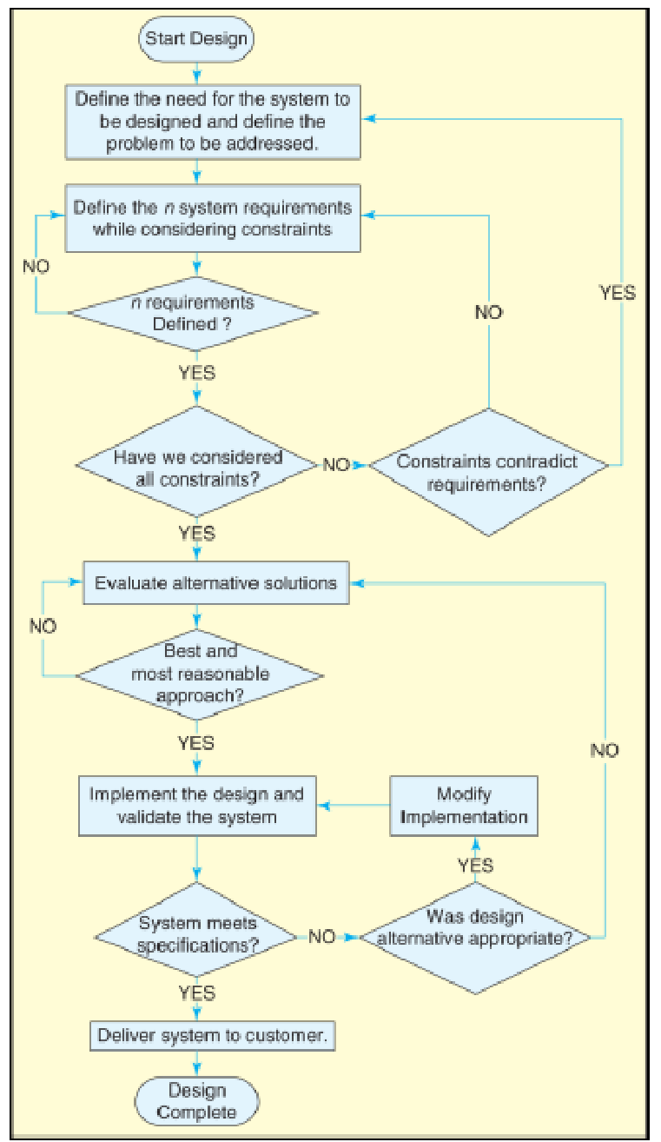
Figure 1 Design Process Flowchart (from Gassert & Enderle, 2008)

REFERENCES
(When a reference, such as a book [1-2], handbook [3], report [4], journal [5], or conference paper [6], or any other document is cited in the text, it should be properly listed in the References section. Use the IEEE Citation Reference format.)
[1] | J. K. Author, “Title of chapter in the book,” in Title of His Published Book, xth ed. City of Publisher, Country if not USA: Abbrev. of Publisher, year, Ch. x, sec. x, pp. xx–xx.
[2] | B. Klaus and P. Horn, Robot Vision. Cambridge, MA: MIT Press, 1986.
[3] | Motorola Semiconductor Data Manual, Motorola Semiconductor Products Inc., Phoenix, AZ, 1989.
[4] | J. H. Davis and J. R. Cogdell, “Calibration program for the 16-foot antenna,” Elect. Eng. Res. Lab., Univ. Texas, Austin, Tech. Memo. NGL-006-69-3, Nov. 15, 1987.
[5] | R. E. Kalman, “New results in linear filtering and prediction theory,” J. Basic Eng., ser. D, vol. 83, pp. 95-108, Mar. 1961.
[6] | C. Berrou, A. Glavieux, and P. Thitimajshima, “Near Shannon limit error-correcting coding and decoding: Turbo-codes. 1,” in Proc. Int. Conf. Commun., Geneva, Switzerland, May 1993, pp. 1064–1070.

