ELE 402 - GRADUATION PROJECT II FINAL REPORT

  - Hacettepe University
Department of Electrical and Electronics Engıneerıng

GROUP NAME (Optional)

Project title: (The title of the ELE 401 – ELE 402 project)

Project group members: (The names of the students who work together in the same project group)

Project supervisor: (Academic title and name of the supervisor)

Submission date:

  - Spring 2025-2026

ABSTRACT
The Abstract is the first section of the final report which contains a brief summary of the entire project report. A single paragraph composed of 5-6 sentences up to half a page is usually considered a decent size for the Abstract section. The purpose and the content of the report should be clearly mentioned. A brief explanation of the work conducted throughout ELE401, and the results obtained in this period should be included.

TABLE OF CONTENTS
ABSTRACT 1
TABLE OF CONTENTS 2
LIST OF FIGURES AND TABLES 3
1. INTRODUCTION 4
2. PROJECT DESCRIPTION 4
3. ENGINEERING STANDARDS AND DESIGN CONSTRAINTS 4
3.1. ENGINEERING STANDARDS 5
3.2. DESIGN CONSTRAINTS 5
4. SUSTAINABLE DEVELOPMENT GOALS 5
5. LITERATURE REVIEW 6
6. METHODS 6
6.1. METHOD 1 (YOU MAY REPLACE WITH THE NAME OF THE METHOD) 6
6.2. METHOD 2 (YOU MAY REPLACE WITH THE NAME OF THE METHOD) 6
7. PRELIMINARY DESIGN 6
8. PROTOTYPE 7
9. DESIGN PROCESS 7
9.1. ITERATION 1 (YOU MAY REPLACE WITH THE NAME OF THE PROCESS) 8
9.1.1. TESTING AND RESULTS 8
9.1.2. EVALUATION 8
9.2. ITERATION 2 (YOU MAY REPLACE WITH THE NAME OF THE PROCESS) 8
9.2.1. TESTING AND RESULTS 8
9.2.2. EVALUATION 8
10. FINAL DESIGN 9
10.1. MEETING THE CONSTRAINTS AND ENGINEERING STANDARDS 9
10.2. COST ANALYSIS 10
11. TEAMWORK 10
12. COMMENTS AND CONCLUSIONS 10
REFERENCES 11

LIST OF FIGURES AND TABLES
Figure 1 9

INTRODUCTION
This template aims to help the students prepare their final report for the ELE 402 Graduation Project II course. The students are required to follow the exact formatting of page setup, page, section, and subsection numbering, referencing, tables and figures as given in this template, as well as the specific instructions regarding the content of the report. The grading of this report will be both over style and content. This report must be submitted by the last day of the final exams.
The report, along with its attachments, should be printed one-sided and punched and placed in a soft binder. The electronic copy of this submission should also be sent to the project supervisor in a single pdf file through e-mail. The pdf file should be named in the format as:
ELE402_semesteryear_FR_groupname or studentname.pdf
Example: ELE402_Spring2026_FR_GroupAlpha.pdf (for group projects)
ELE402_Spring2026_FR_CanYazar.pdf (for individual projects)
Similar to the interim reports, this section is expected to provide general information about the overall project, the progress made during previous report terms, as well as what has been accomplished specifically throughout the remainder of the semester. It should clearly mention the additional work that has been conducted after the interim report has been submitted. A summary of the information given in the following sections should also be included at the end. Recall that the Introduction section is usually not comprised of subsections.

PROJECT DESCRIPTION
The main body of the final report starts here. The subsections of this report are a combination of the previous reports. The following sections and subsections are expected to be included in this report; more sections may be added, if necessary. Although these sections appear to be identical to those in the previous reports, they are expected to contain more detail and should be written with more care than before. If any information provided in the corresponding subsections of the previous reports has been found incomplete or incorrect, this report will be an opportunity to present the latest and most up to date result and overall progress.

ENGINEERING STANDARDS AND DESIGN CONSTRAINTS
The design should be subject to engineering standards and/or multiple realistic constraints. There should be at least one standard, and one constraint mentioned in this report. These chosen standards and constraints must be followed and applied throughout the rest of the project, so it is important that they be identified accordingly at this point.

ENGINEERING STANDARDS
This section of the report aims to clarify which engineering standard(s) apply to this design project and how the design project is expected to satisfy these standards.
Include the necessary standard(s) from the checklist you have selected in your interim report. Provide a thorough discussion regarding the standard(s)’ possible relevance to your project. As an example, if you are using IEEE 802.11 standard in your design you are expected to go through that standard and discuss here how you will utilize, and have utilized so far, this standard in your design. An example list of engineering standards is given below. More examples of standards can be found in the Project Design Constraints document.

DESIGN CONSTRAINTS
The design constraints should be identified and some discussion on how these apply to the design project and their realization are to be included in this section. You may refer to the list of some realistic design constraints that can be found in the Project Design Constraints document. Other constraints can be identified and discussed, if applicable.

SUSTAINABLE DEVELOPMENT GOALS
The Sustainable Development Goals (SDGs), also known as the Global Goals, were adopted by all United Nations Member States in 2015 as a universal call to action to end poverty, protect the planet and ensure that all people enjoy peace and prosperity by 2030.
There are 17 SDGs which are; Goal 1: No poverty, Goal 2: Zero hunger, Goal 3: Good health and well-being for people, Goal 4: Quality education, Goal 5: Gender equality, Goal 6: Clean water and sanitation, Goal 7: Affordable and clean energy, Goal 8: Decent work and economic growth, Goal 9: Industry, Innovation, and Infrastructure, Goal 10: Reducing inequalities, Goal 11: Sustainable cities and communities, Goal 12: Responsible consumption and production, Goal 13: Climate action, Goal 14: Life below water, Goal 15: Life on land, Goal 16: Peace, justice and strong institutions, Goal 17: Partnerships for the goals. You may find detailed information about the goals at https://www.undp.org/content/undp/en/home/sustainable-development-goals.html.
Clearly state which Goals are satisfied by your project and how. Elaborate on your reasoning by providing sufficient detail for the Goals you mention.

LITERATURE REVIEW
In this section, provide the theoretical background from courses taken during the first three years of the undergraduate program that will be applied in the project, and the further research and literature studies you conduct to reach your design constraints, meet the engineering standards and fulfill your project in general. Discuss relevant topics, including available methods, tools, and, if necessary, mathematical formulae and derivations. As the knowledge acquired in previous coursework is typically insufficient for completing the project, additional research—such as literature reviews, advanced theoretical or practical studies, or expertise in specific fields, software, or hardware—may be required. Any essential background knowledge not covered in previous coursework should also be presented in this section, with proper references in IEEE format.

METHODS
In this section, clearly define the approaches or methods that you chose to employ to achieve the objectives of the project. Provide detailed justification for the selection of each method, considering its relevance, feasibility, and effectiveness in addressing the project’s requirements. Where applicable, compare alternative approaches you opted out of, and discuss their limitations compared to your choice of methods. Ensure that the chosen methodologies align with established engineering standards and best practices, supporting the overall success of the project. Please give citations when you use references for each method in IEEE format.

METHOD 1 (YOU MAY REPLACE WITH THE NAME OF THE METHOD)
Explain the first method in detail. Explain advantages and disadvantages. Use references. Use figures when necessary.

METHOD 2 (YOU MAY REPLACE WITH THE NAME OF THE METHOD)
Explain the first method in detail. Explain advantages and disadvantages. Use references. Use figures when necessary.

PRELIMINARY DESIGN
Based on the methods provided in the previous section,
- Choose one of the methods and explain the reasoning behind your choice.
- Provide a preliminary design using the chosen method. Use figures, flow charts, etc. in order to describe the preliminary design.
- Clearly identify the parameters and design choices in the preliminary design. At this stage, you do not need to determine the value of the parameters. You do not need to make design choices. However, you do need to identify what the parameters and design choices are.

PROTOTYPE
In this section, introduce and describe the hardware/software prototype. Clearly indicate
- the purpose for building the prototype,
- what the prototype does,
- an overview of its key features.
If appropriate, include a photograph, flowchart, or another visual source for the prototype.

DESIGN PROCESS & PROGRESS
In this section, present the steps of the design process performed in constructing the prototype. The engineering design process is a series of steps that engineers follow to solve a design problem and often involves an iterative process. Iteration is, in general, defined as the act of repeating something over and over again to improve the process and eventually achieve the desired goal. In a typical design loop, first a solution is generated, second the solution is implemented, and third the result of the implementation is tested and evaluated. If the results do not satisfy the requirements, additional solutions are generated, and the above three-step process starts over again. This cycle and iteration continue until satisfactory results are obtained and the desired goal is achieved. An example flow chart that shows the design process is given in Fig. 1.
In the following subsections, discuss how the design is modified in each iteration by providing and evaluating the results obtained during testing, including difficulties encountered and novel solutions proposed. Additionally, provide discussion regarding the key findings from your previous iteration that you used in the improvement of your next iterations.

ITERATION 1 (YOU MAY REPLACE WITH THE NAME OF THE PROCESS)
Explain the first iteration in your prototype design.

TESTING AND RESULTS
Describe how the requirements were tested, provide results that show what you obtained, and interpret the results, including whether the requirements were satisfactorily satisfied.

EVALUATION
Honestly assess the strengths and weaknesses of your design and develop novel solutions if certain requirements are not met. Clearly discuss what modifications and solutions are needed to improve the design.

ITERATION 2 (YOU MAY REPLACE WITH THE NAME OF THE PROCESS)
If the design is not validated in the first iteration, explain the second iteration in this section. Clearly explain what modifications were performed to improve the design.

TESTING AND RESULTS
Describe how the requirements were tested, provide results that show what you obtained, and interpret the results, including whether the requirements were satisfactorily satisfied.

EVALUATION
Honestly assess the strengths and weaknesses of your design and develop novel solutions if certain requirements are not met. Clearly discuss what modifications and solutions are needed to improve the design.
(Include new subsections 3.3, 3.4, etc., if additional iterations were performed to reach the prototype design. Discuss the strengths and weaknesses of your prototype design in the last iteration and suggest novel solutions to be performed in the final design.)
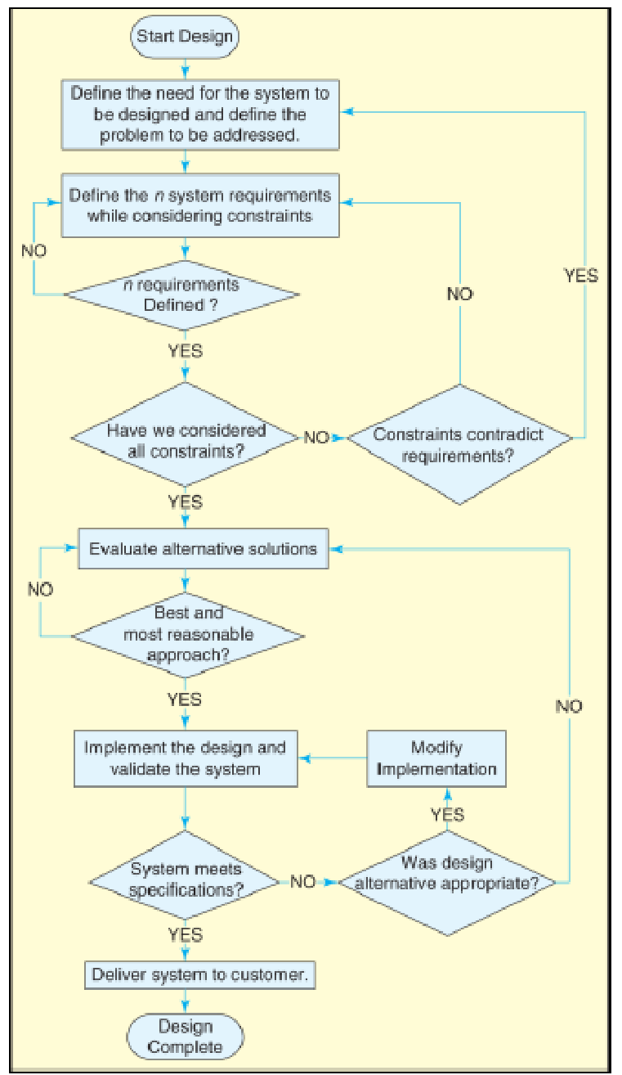
Figure 1 Design Process Flowchart (from Gassert & Enderle, 2008)

FINAL DESIGN
Describe the final design in detail.
- Indicate the methods used in the final design and explain the reasoning behind your choice. Use figures, flow charts, etc. in order to describe the final design.
- Clearly identify the parameters and design choices in the final design.
- Provide the results of testing for the final design.
- Assess the strengths and weaknesses of your final design and discuss whether the requirements are met in the final design.

MEETING THE CONSTRAINTS AND ENGINEERING STANDARDS
Discuss how the final design satisfies the engineering standards and multiple constraints identified previously.

COST ANALYSIS
Itemize the cost of each component of the final product and discuss the cost effectiveness of the project.

TEAMWORK
This section is dedicated to clarifying the details of the team’s efforts if the project is conducted by a group of students. How the workload has been split up amongst the group members needs to be clearly explained in this section. Each member’s individual contributions to the project must be visible to the reader.

COMMENTS AND CONCLUSIONS
The inclusion of the comments and conclusions section is mandatory in the term report. It should start with a detailed summary of the report and present an elaborate picture of the final status of the design project. The author is expected to briefly discuss the results obtained in terms of goals set for the complete project, accuracy, sufficiency, etc. Finally, the steps of the proposed future studies need to be indicated.

REFERENCES
(When a reference, such as a book [1-2], handbook [3], report [4], journal [5], or conference paper [6], or any other document is cited in the text, it should be properly listed in the References section. Use the IEEE Citation Reference format.)

[1] | J. K. Author, “Title of chapter in the book,” in Title of His Published Book, xth ed. City of Publisher, Country if not USA: Abbrev. of Publisher, year, Ch. x, sec. x, pp. xx–xx.
[2] | B. Klaus and P. Horn, Robot Vision. Cambridge, MA: MIT Press, 1986.
[3] | Motorola Semiconductor Data Manual, Motorola Semiconductor Products Inc., Phoenix, AZ, 1989.
[4] | J. H. Davis and J. R. Cogdell, “Calibration program for the 16-foot antenna,” Elect. Eng. Res. Lab., Univ. Texas, Austin, Tech. Memo. NGL-006-69-3, Nov. 15, 1987.
[5] | R. E. Kalman, “New results in linear filtering and prediction theory,” J. Basic Eng., ser. D, vol. 83, pp. 95-108, Mar. 1961.
[6] | C. Berrou, A. Glavieux, and P. Thitimajshima, “Near Shannon limit error-correcting coding and decoding: Turbo-codes. 1,” in Proc. Int. Conf. Commun., Geneva, Switzerland, May 1993, pp. 1064–1070.

